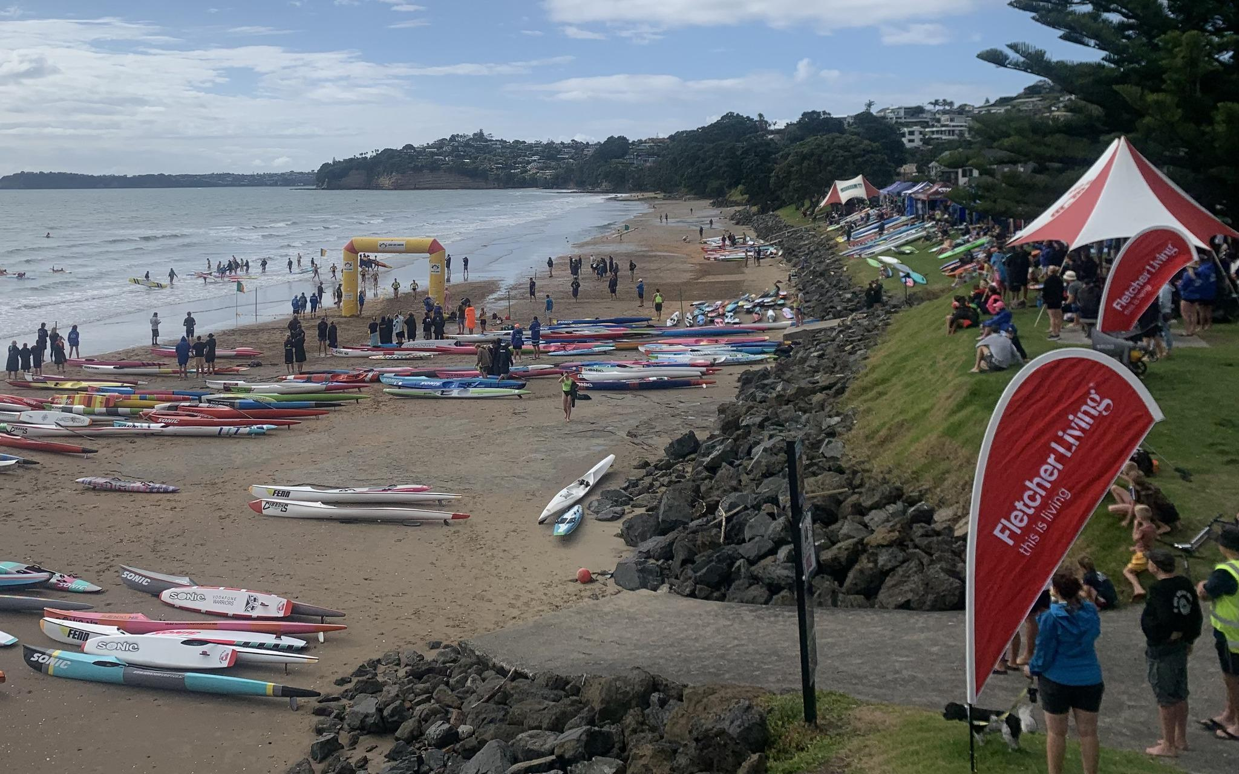
68th Owen Chapman Cup
Red Beach SLSC
Prize money for Individual and Team winners per age group.
Thank you to all our event sponsors
13/01/2024
Owen Chapman Event Memo

The Owen Chapman event is a Red Beach run SLS event. The event is put on by the club's volunteers and its membership and is in its 68th year of running. The event is a great hit out after the Christmas and New Year period and provides some quality racing before the Eastern Regional Championships later in January. Clubs compete for a shot at the title of both the Owen Chapman Cup (Northern Region clubs only) and the Jubilee Cup (All regions). Every event is supported by local sponsors which provide athletes with a shot at winning some cash too. This is a Goodwill event so there is a no-protest rule, however, any issues will be considered in good faith with a competitor-focused approach.

Entry Process
Entries are due by the 8th of January 2024.
The cost of entry is $30.00 per competitor.
The entry process will go through Gameday - Follow the link below.
https://2024owenchampancompetition.events.mygameday.app/
Late entries and walk-up entries will be available on the day at a cost of $40.00.
All late entries must be in before 7.45am on the day of racing.
Team entries are put though on the day at Marshalling - Any teams/individuals to miss registration will miss out.

Event Timings
Meeting for Officials - 7.15 am
Meeting for Team Managers - 7.30 am
Late Registrations - 7.15 - 7.45 am upstairs
First Event Marshall - 8.15 am
Frist Event - 8.30 am

Program
(first event from 8.30am)
Board Heats (Opens, u/19s, u/17s, u/15s)
Board Finals (Opens, u/19s, u/17s, u/15s)
Surf Race Straight Finals (Opens, u/19s, u/17s, u/15s)
Ski Heats (Opens, u/19s, u/17s, u/15s)
Ski Finals (Opens, u/19s, u/17s, u/15s)
Mixed U/15 Diamond Race (Swim first - Straight Final)
Ski Relays (Opens, u/19s, u/17s)
Board Relays (Opens, u/19s, u/17s)
Taplins (Opens, u/19s, u/17s)
Sprints (Opens, U19s, u/17s, u/15s)
Sprint Relays (Opens, U19s, u/17s)
Flags (Opens, u/19s, u/17s, u/15s)
Female Eliminator (All ages)
Male Eliminator (All ages)

All individual events will be run by age group.
Team events will run U17/U19/Open
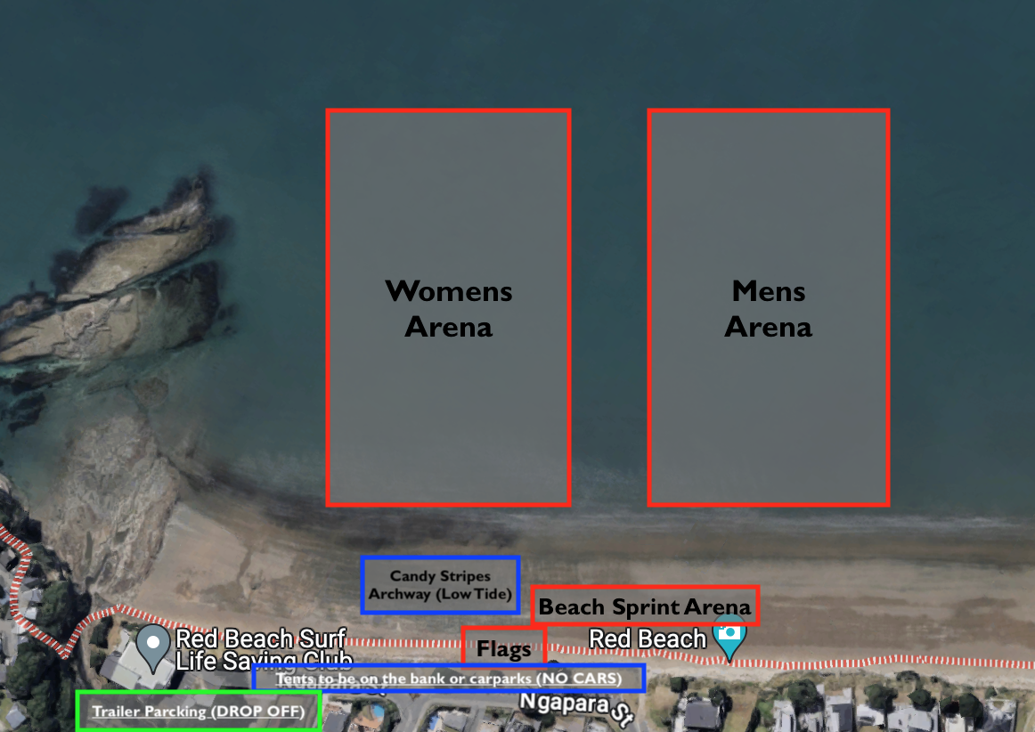

PLEASE NOTE;
Due to the tides, there will be no space to put tents on the beach - Tents will need to go on either the bank or the car parks along the front of the beach.
No cars are to be parked along the front of the beach as this space will need to be used for gear storage and tent locations.
Please try and arrange carpooling as there will be very limited spaces to park.
Additional trailers can be dropped in the reserve. Cars will need to unhitch trailers and find parking elsewhere.
Placing and Prize money
Prize money will be awarded to individual winners per event per age group
Prize money will be awarded to the winning team only per age group, per event.
All U15s will race in U17 team events
Event Rules;
Please Note:
- Individuals cannot race up age groups – You must race in your own individual age group only for the Individual events.
- Competitors can race up age groups in team events to fill teams, however, relays will not be held for athletes competing in multiple age groups.
- Depending on numbers, U19 & Open team events may be run together but have separate results. U19 athletes in open teams must declare their team age group with officials before racing and record at finish accordingly.
- Flags & sprints cash prizes will be awarded to the athlete with the best results over both events (there is no prize money for each individual event, only a combined score prize).
- Separate memo for the eliminator.
- Composite teams are welcomed but will not be eligible for prize money or points.
- Male & female arenas to be identical. Any changes to the program/structure of heats must be approved by Event Controller.
- This is a Goodwill event so there is a no-protest rule, however, any issues will be considered in good faith with a competitor-focused approach.
- Course layouts may vary from the typical guidelines in the SLSNZ competition manual. This is at the pure discretion of the event referee.
- The judge's decision is final.

